Encuentra los meses del año
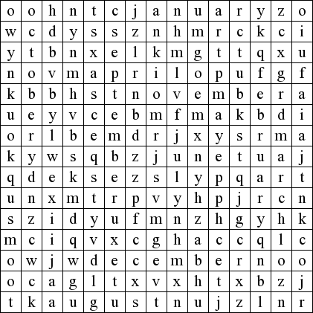







November
June
December
March
September
July
February
May
October
January
August
April
January

