YOUR FAVORITE MOVIE – the facts
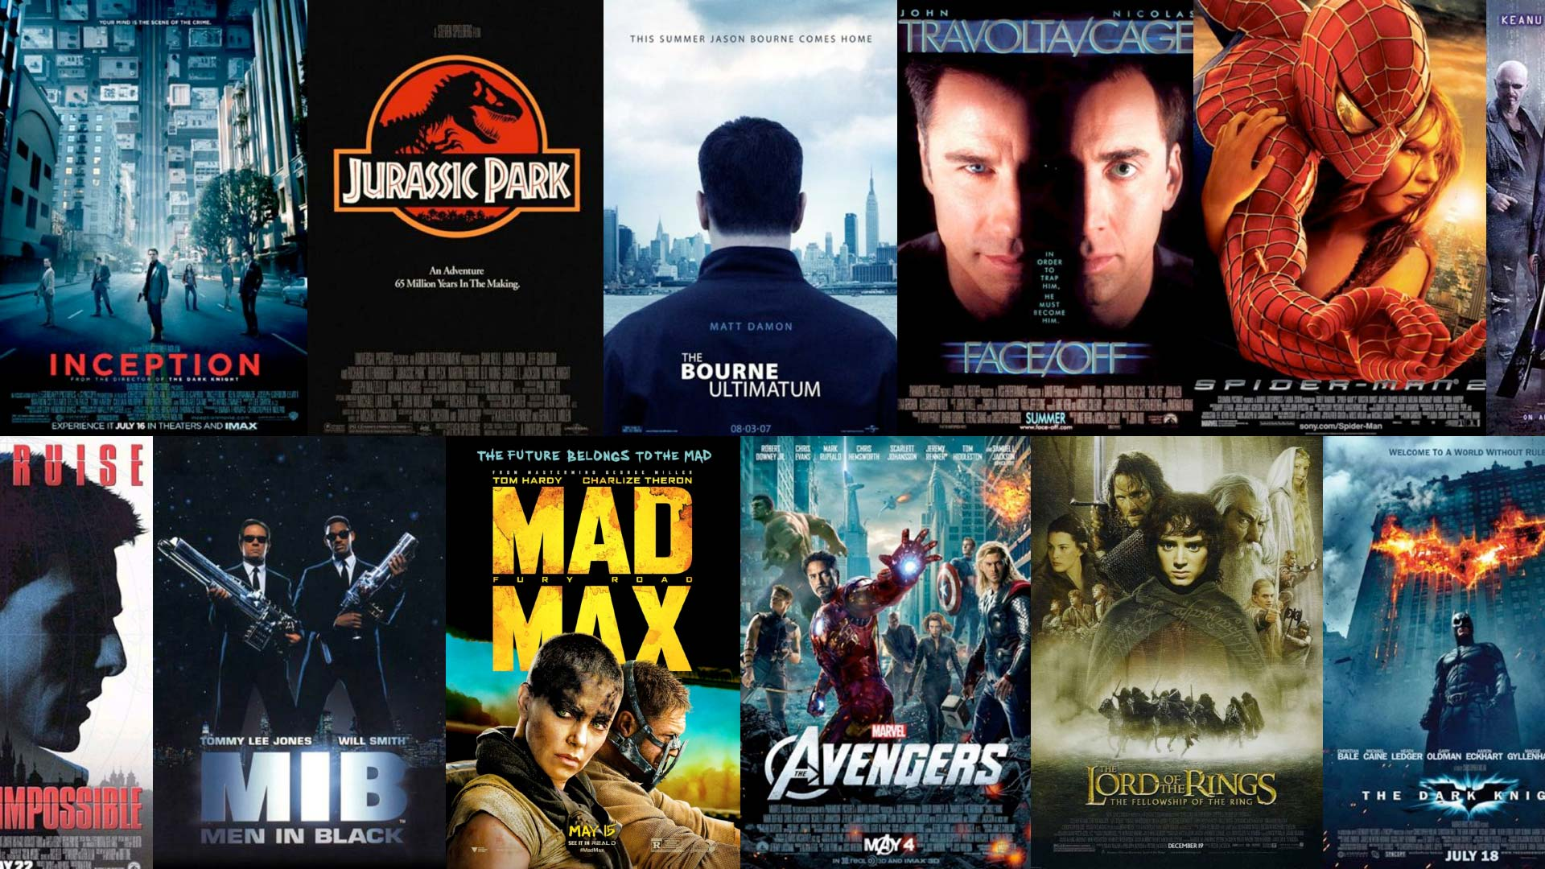
1 – Title:
2 – Category:
3 – Country/countries:
4 – Cast (Actors/actresses and roles):
5 – Year:
6 – How many times did you watch this film?
7 – When did you first see this movie?

YOUR FAVORITE MOVIE – the details

1 – Why do you like the film?
2 – What made you select this one as your favorite?
3 – Who have you watched this film with?
4 – Did you cry? If not, why? If so, why?
5 – What is the movie about?
6 – What kind of movies do you like to watch? What kind do you avoid?

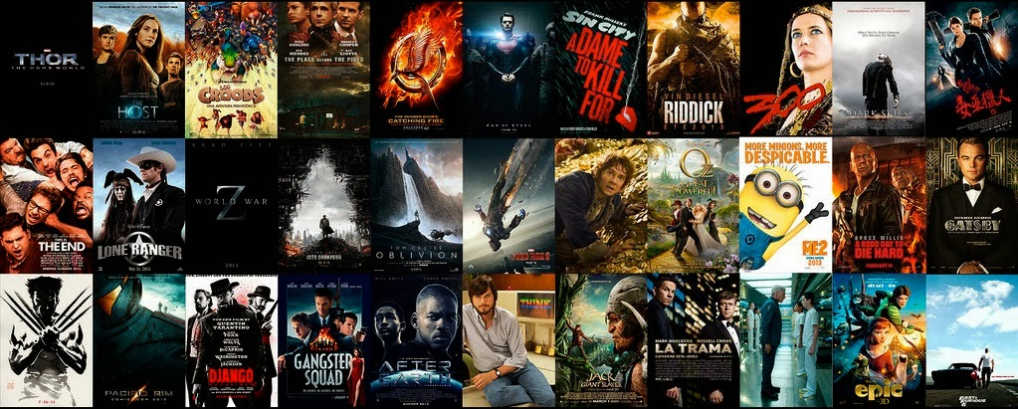

YOUR TEACHER’S FAVORITE MOVIE IS ‘STAR WARS: THE EMPIRE STRIKES BACK’. NOW LISTEN TO THE DIALOGUE AND COMPLETE WITH THE VERBS IN THE BOX
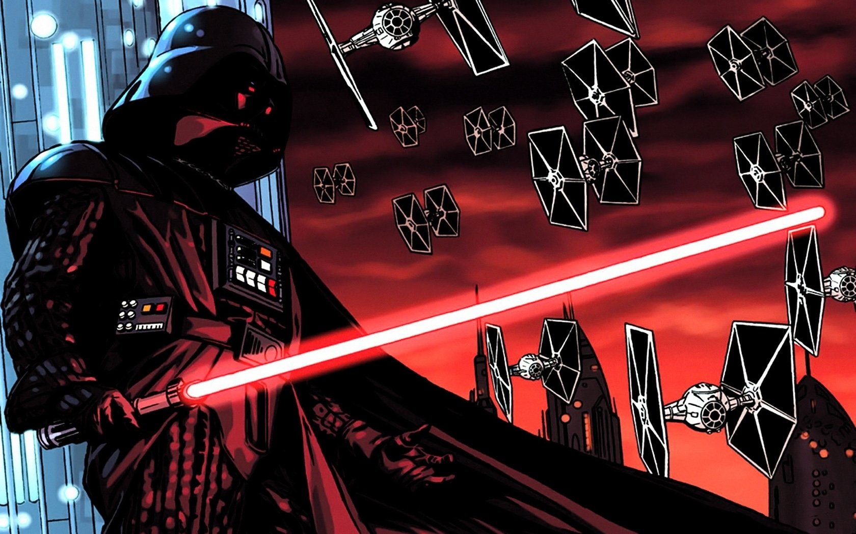
https://www.youtube.com/watch?v=hhwSbHytvuU&t=1s

LISTEN AND COMPLETE THE TEXT
Began (X2) – was (x3) – turned - wasn’t – grew – recognized – demonstrated – became – fell – fought – changed – introduced - met

It all __________ with Anakin Skywalker. Anakin _____ the most accomplished board racer. He _____ just a boy when I first met him. Anakin ______________ abilities far beyond his years, which explains how he ______ able to build something as intricate and indeed perfect as me. (Well, I _______ naked for long, anyway). Everything _______ when the Jedi came to Tatooine. Qui Gon Jinn ______________ Anakin’s potential and _____________him to his future Jedi master. He also _____ a girl who would become the love of his life: Padmé Amidala. Master Anakin ______ up to be a handsome young man. And a very powerful Jedi. But then, he _____deeply in love with Padmé, disobeying his Jedi vows. Well, you do not always do what you are told either. Anakin _________ bravely at the terrible battle which ______ the Clone Wars. But tragically, he _______ to the dark side, ________ Darth Vader, the worst villain in the galaxy.

