ACTIVIDADES SEMANA DEL 27/4 AL 3/5 INGLÉS TERCER AÑO 1, 2 y 3 LICEO N° 6

Read the following text.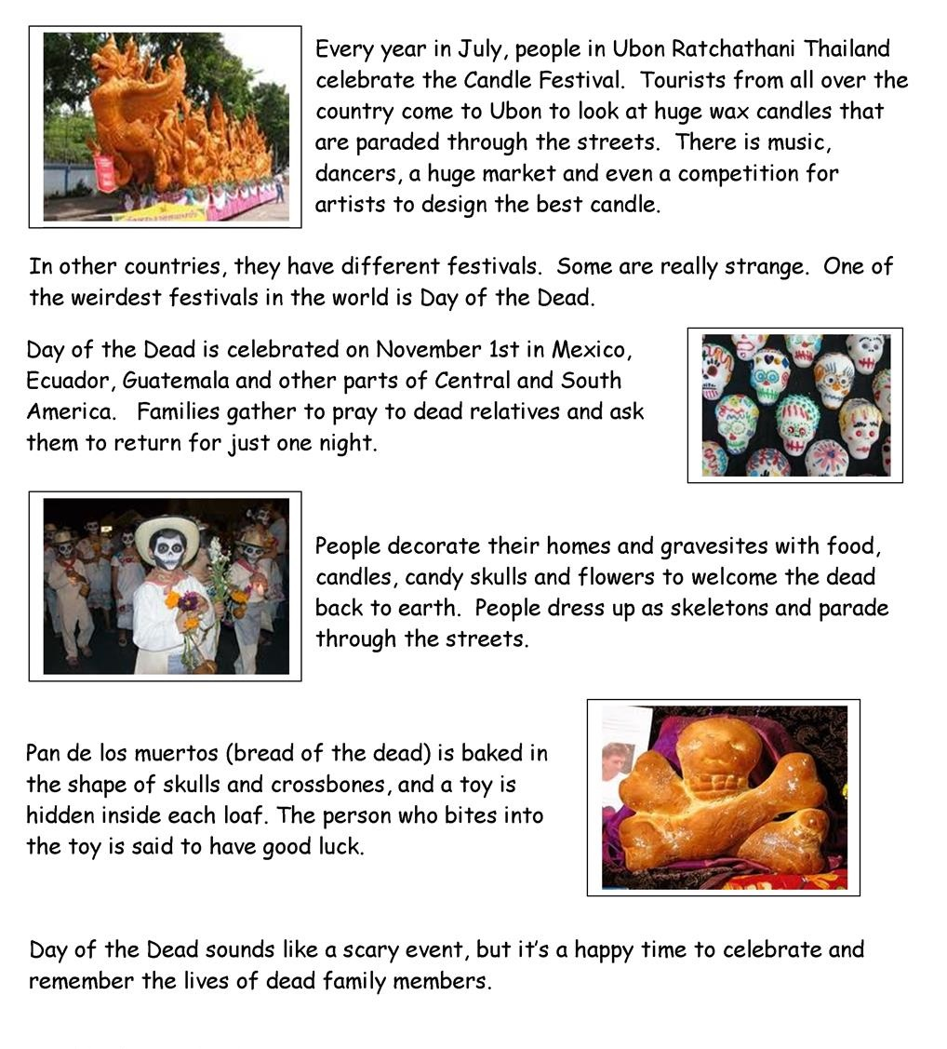
Answer True (T) or False (F). Correct the false ones. There is an example already done for you.

0 – Day of the Dead is Celebrated in July – F. Day of the dead is celebrated in November.

1 – Families ask dead people to come back for one night.
2- Pan de los muertos is a type of bread.
3 - It is unlucky to bite the toy in pan de los muertos.
4 - Day of the dead is a happy festival.
5 - Day of the Dead is celebrated in Africa.

Read the text again. Answer the following questions. Write full answers:

1 - Why do people celebrate Day of the Dead?
2 - What do people put in Pan de los Muertos?
3 - How often do people celebrate Day of the Dead?

